**Experiment 2.1**

**Student Name: Gaurav Kumar                                     UID: 22MCC20177**

**Branch: CC-DEVOPS Section/Group : 1/B**

**Semester: 1                                                                    Date of Performance: 18/NOV/2022**

**Subject Name : Python Programming                         Subject Code: 22CAH645**

1. **Task to be done: Write an experiment to swap two columns in numpy araray.**

**Steps for experiment/practical:**

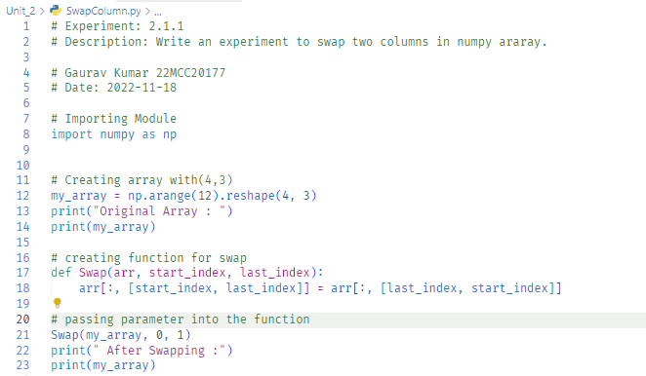

**Output (screenshots):**

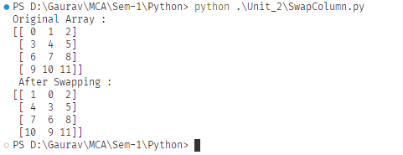

1. **Task to be done: Write an experiment import a dataset with numbers and texts keeping the text intact in python numpy?**

**Steps for experiment/practical:**

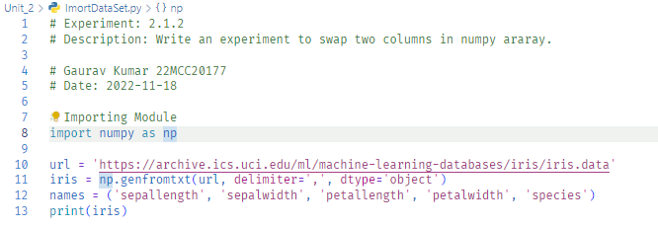

**Output (screenshots)**

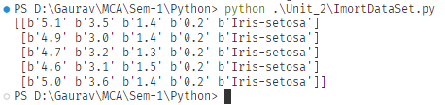

**4) Learning outcomes (What I have learnt): Times new roman 12 size**

**1. Learn about Numpy.**

**2. Learn about swapping and slicing.**

**3. Learn about how to use csv in numpy.**

**Evaluation Grid:**

|  |  |  |  |
| --- | --- | --- | --- |
| Sr. No. | Parameters | Marks Obtained | Maximum Marks |
| 1. | Demonstration and Performance  (Quiz) |  | 22 |
| 2. | Worksheet |  | 8 |